ASSIGNMENT – 3.3
Name: P Ashwitha
Batch: 24
HT No: 2303A51163
Task 1: AI-Generated Logic for Reading Consumer Details
Scenario
An electricity billing system must collect accurate consumer data.
Task Description
Use an AI tool (GitHub Copilot / Gemini) to generate a Python program that:
• Reads:
o Previous Units (PU)
o Current Units (CU)
o Type of Customer
• Calculates units consumed
• Implements logic directly in the main program (no functions)
Expected Output
• Correct input reading
• Units consumed calculation
• Screenshot showing AI-generated code
• Sample input and output
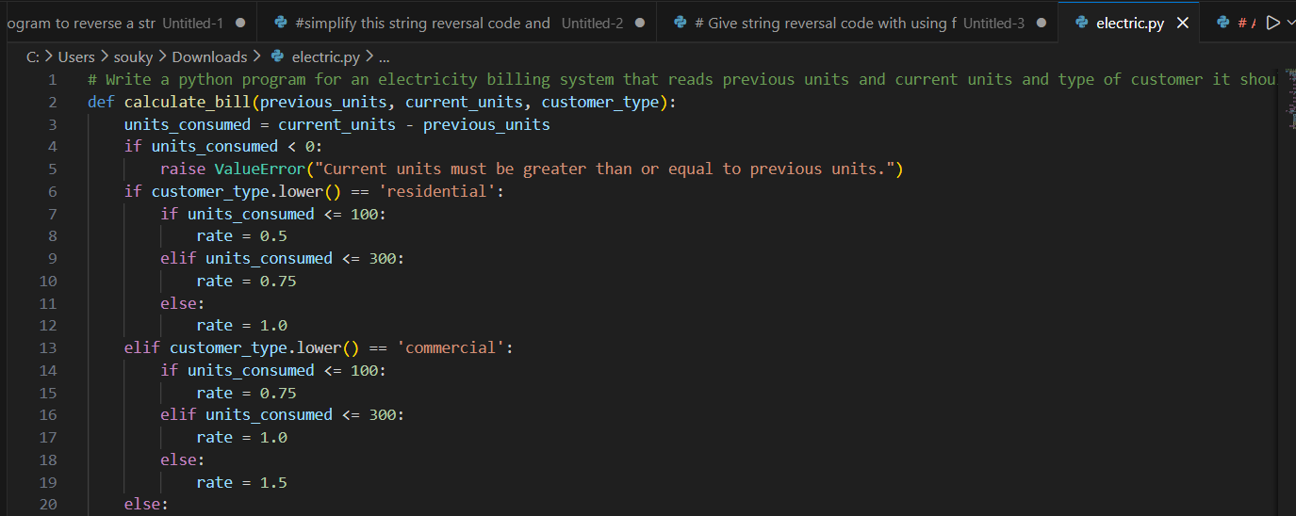
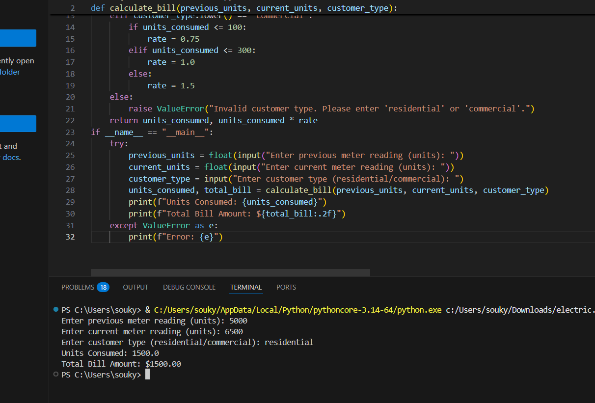
Task 2: Energy Charges Calculation Based on Units Consumed
Scenario
Energy charges depend on the number of units consumed and customer type.
Task Description
Review the AI-generated code from Task 1 and extend it to:
• Calculate Energy Charges (EC)
• Use conditional statements based on:
o Domestic
o Commercial
o Industrial consumers
• Improve readability using AI prompts such as:
o “Simplify energy charge calculation logic”
o “Optimize conditional statements”
Expected Output
• Correct EC calculation
• Clear conditional logic
• Original and improved versions
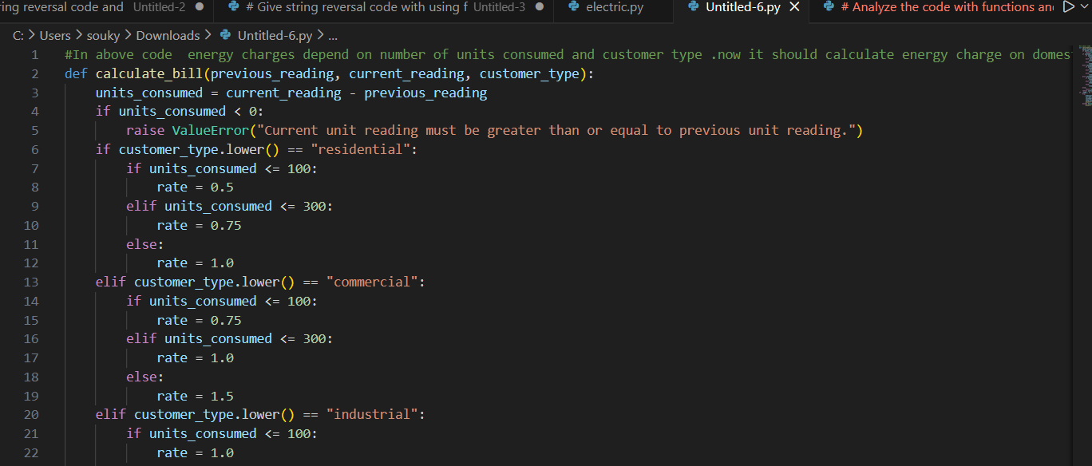
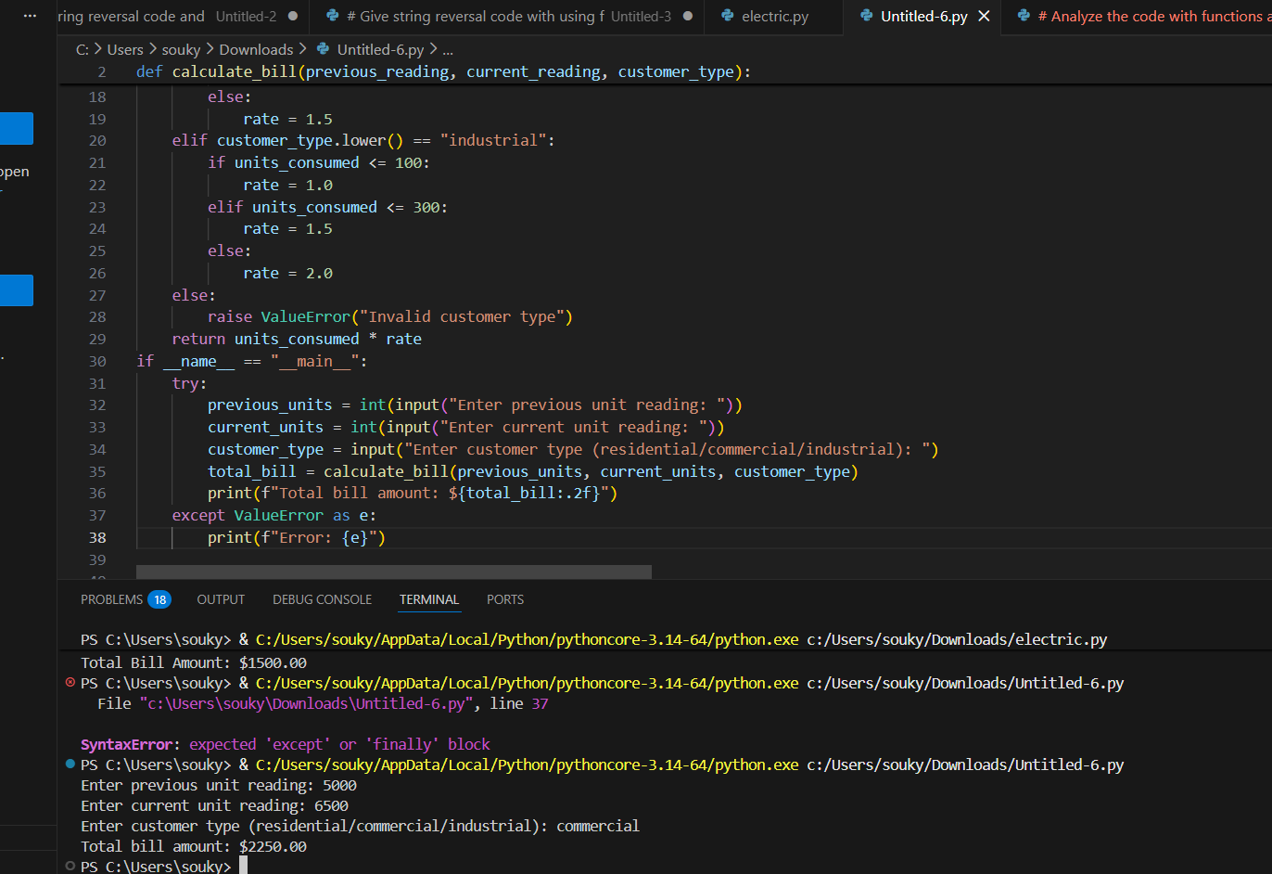
Task 3: Modular Design Using AI Assistance (Using Functions)
Scenario
Billing logic must be reusable for multiple consumers.
Task Description
Use AI assistance to generate a Python program that:
• Uses user-defined functions to:
o Calculate Energy Charges
o Calculate Fixed Charges
• Returns calculated values
• Includes meaningful comments
Expected Output
• Function-based Python program
• Correct EC and FC values
• Screenshots of AI-assisted function generation
• Test cases with outputs
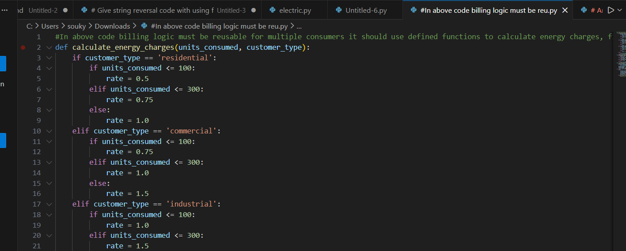
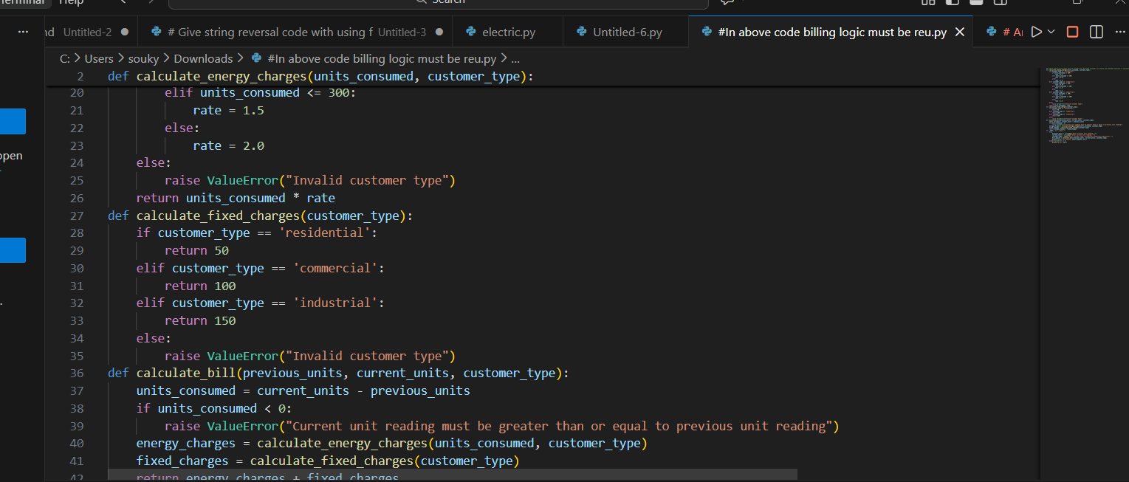
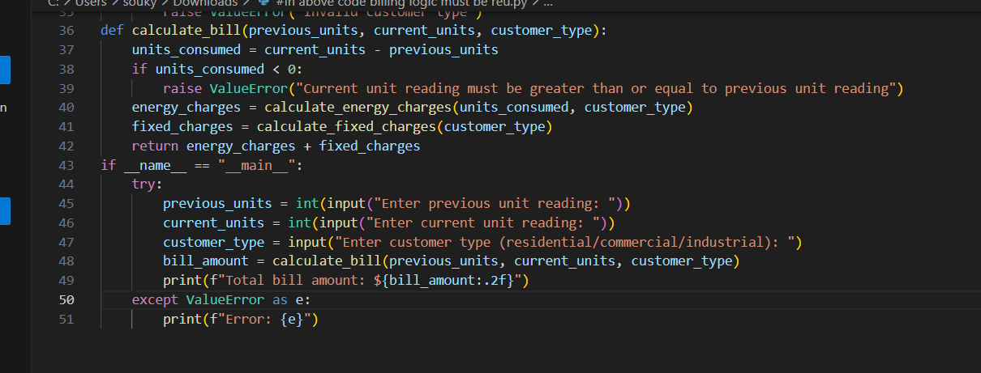
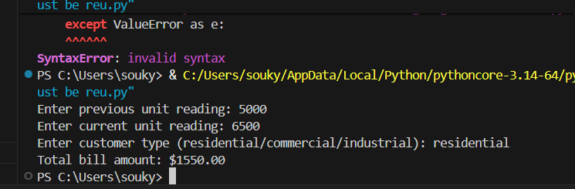
Task 4: Calculation of Additional Charges
Scenario
Electricity bills include multiple additional charges.
Task Description
Extend the program to calculate:
• FC – Fixed Charges
• CC – Customer Charges
• ED – Electricity Duty (percentage of EC)
Use AI prompts like:
• “Add electricity duty calculation”
• “Improve billing accuracy”
Expected Output
• Individual charge values printed
• Correct duty calculation
• Well-structured output
• Verified intermediate results
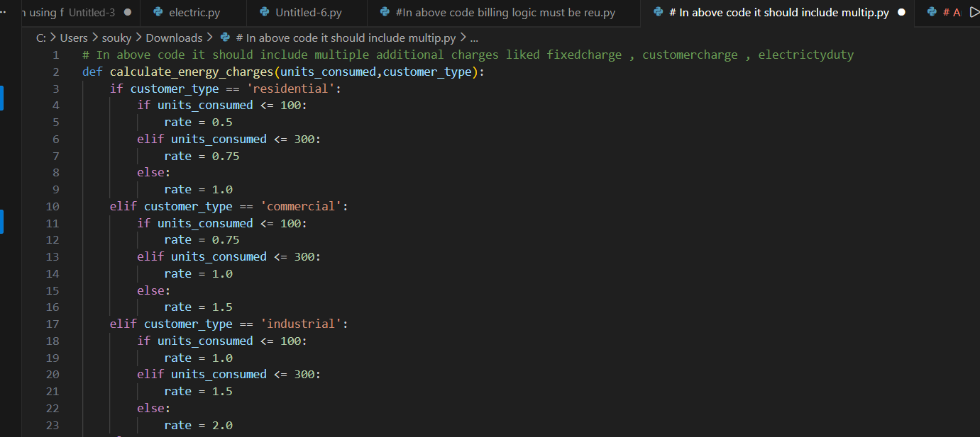
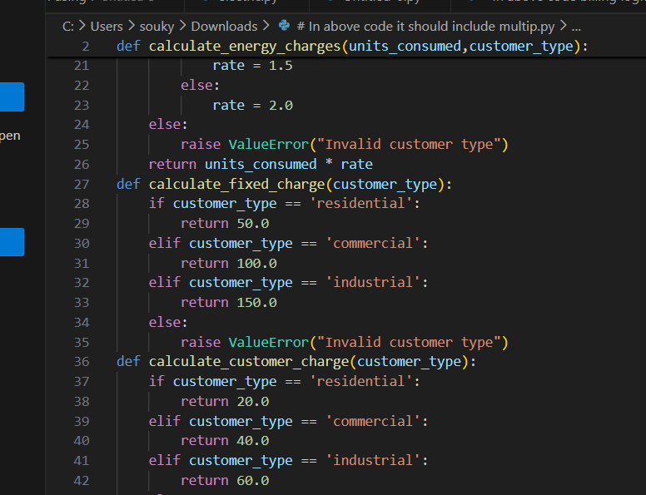
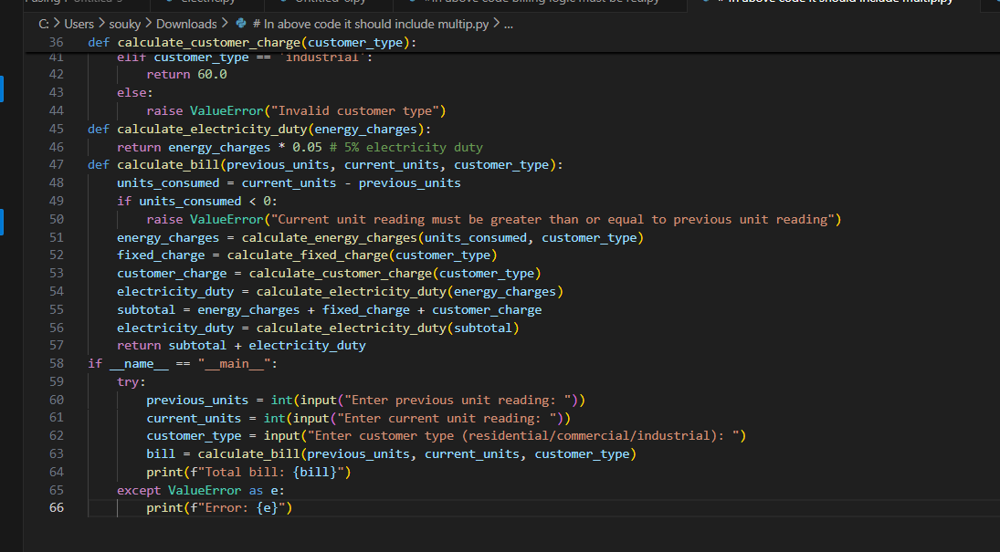
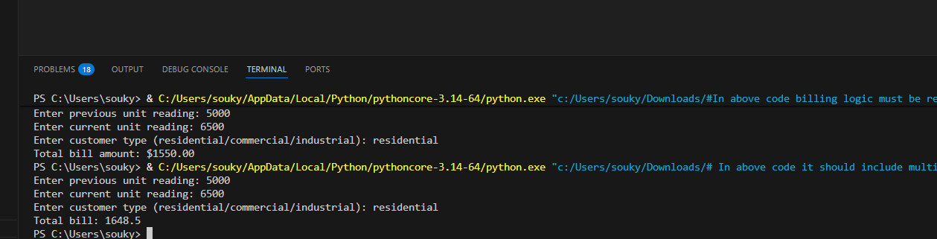
Task 5: Final Bill Generation and Output Analysis
Scenario
The final electricity bill must present all values clearly.
Task Description
Develop the final Python application to:
• Calculate total bill:
• Total Bill = EC + FC + CC + ED
• Display:
o Energy Charges (EC)
o Fixed Charges (FC)
o Customer Charges (CC)
o Electricity Duty (ED)
o Total Bill Amount
• Analyze the program based on:
o Accuracy
o Readability
o Real-world applicability
Expected Output
• Complete electricity bill output
• Neatly formatted display
• Sample input/output
• Short analysis paragraph

